**Project Report**

Project Mentor: Chirag Sir





Department of Animation, IT-IMS and Mobile Application

Navrangpura, Ahmedabad - 380009, Gujarat

Project Submitted by :- Harsh Vekariya,

Mehta Vrushal, Dviyam Jain, Patel Prit

# Index

1. Title Page
2. Table of Contents
3. Introduction
   * 3.1 About Organization
   * 3.2 About the Project
   * 3.3 Objectives
4. Literature Review
   * 4.1 Overview of Online Education Platforms
   * 4.2 Key Features and Functionalities
5. Development Process
   * 5.1 UI/UX Design in Figma
   * 5.2 Frontend Development
   * 5.3 HTML Structure
   * 5.4 CSS Styling
   * 5.5 JavaScript Interactivity
   * 5.6 Backend Development with PHP
   * 5.7 Database Connectivity
6. Results
   * 6.1 Key Features Implemented
   * 6.2 User Feedback
7. Discussion
   * 7.1 Analysis of Results
   * 7.2 Challenges Faced
8. Conclusion

1. **About the Organization**



Enlightened is an innovative online platform designed to revolutionize the way learners access and engage with educational content. The website features a user-friendly interface that allows users to seamlessly explore and enrol in a diverse range of courses across various categories, including technology, business, arts, and more.

One of the key aspects of Enlightened is its secure authentication system, which includes robust sign-up, login, and session management features to ensure that user data is protected and user access is personalized. Once logged in, users can view and manage their profiles, where they can keep track of their enrolled courses.

The platform is designed to offer a highly personalized learning experience. Users can browse through course listings with detailed descriptions, helping them make informed decisions about their educational pursuits. The website also includes functionalities for adding courses to a personalized library, viewing detailed course information, and removing courses as needed. These features make it easy for users to manage their learning journey and focus on their educational goals.

Overall, Enlightened provides a comprehensive and secure environment for users to enhance their knowledge and skills, making education more accessible and engaging for everyone.

# 2. About the Project

Enlightened is an innovative online platform designed to revolutionize the way learners access and engage with educational content. The website features a user-friendly interface that allows users to seamlessly explore and enroll in a diverse range of courses across various categories, including technology, business, arts, and more. This project aims to create a comprehensive educational hub that caters to the needs of modern learners.

One of the key aspects of Enlightened is its secure authentication system, which includes robust sign-up, login, and session management features to ensure that user data is protected and user access is personalized. The platform's authentication system is built to handle user registration and login efficiently, maintaining the security and privacy of user information through encrypted data storage and secure session handling.

Once logged in, users can view and manage their profiles, where they can keep track of their enrolled courses. The profile management system provides users with the ability to update their personal information, track their course progress, and access personalized recommendations based on their learning history and preferences.

The platform is designed to offer a highly personalized learning experience. Users can browse through course listings with detailed descriptions, helping them make informed decisions about their educational pursuits. The website also includes functionalities for adding courses to a personalized library, viewing detailed course information, and removing courses as needed. These features make it easy for users to manage their learning journey and focus on their educational goals.

Enlightened also includes an interactive dashboard where users can view all their enrolled courses, access course materials, and track their progress. The dashboard provides a comprehensive overview of the user’s learning activities and helps them stay organized and motivated.

Overall, Enlightened provides a comprehensive and secure environment for users to enhance their knowledge and skills, making education more accessible and engaging for everyone. By integrating robust authentication, personalized course management, and an intuitive user interface, Enlightened aims to be a leading platform in the online education space, fostering continuous learning and personal development.

# 3.Objectives

**Increase User Registration**:

* **Objective**: Achieve a 30% increase in user registrations within the first six months of the website launch.
* **Rationale**: Higher user registrations will indicate greater interest and engagement with the free courses offered, validating the platform’s value.

**Enhance User Engagement**:

* **Objective**: Increase the average time users spend on the website to at least 15 minutes per session within three months.
* **Rationale**: Improved user engagement signifies that users find the content valuable and are more likely to complete courses and return for more.

**Course Completion Rates**:

* **Objective**: Attain a 50% course completion rate within the first year.
* **Rationale**: A high course completion rate demonstrates the effectiveness and appeal of the courses offered.

**User Feedback and Satisfaction**:

* **Objective**: Achieve an average user satisfaction rating of 4.5 out of 5 within six months.
* **Rationale**: Positive user feedback and high satisfaction ratings will help attract more users and improve the platform’s reputation.

# 4. Literature Review

**Overview of Online Education Platforms**

**Growth of E-Learning**:

* **Trend**: The e-learning industry has seen significant growth, driven by increasing internet accessibility and a demand for flexible learning solutions.
* **Insight**: Understanding this trend helps justify the need for a course selling website.

**Free vs. Paid Courses**:

* **Trend**: Free courses attract a larger user base but may suffer from lower completion rates compared to paid courses.
* **Insight**: Offering free courses can boost initial user engagement, but strategies to enhance completion rates (e.g., certifications, interactive content) are essential.

**User Engagement**:

* **Research Findings**: High-quality content, interactive elements, and community features improve user engagement and course completion rates.
* **Insight**: Incorporating these features into the website can enhance user experience and outcomes.

**Technology and Accessibility**:

* **Trend**: Mobile-friendly design and fast load times are crucial for accessibility and user retention.
* **Insight**: Ensuring the website is optimized for various devices will cater to a broader audience.

**Monetization Strategies**:

* **Research Findings**: Effective monetization strategies include offering premium courses, certifications, and partnerships with educational institutions.
* **Insight**: Exploring these strategies can provide financial sustainability while keeping basic courses free.

**Marketing and Outreach**:

* **Trend**: Digital marketing, including social media and SEO, is critical for reaching potential users.
* **Insight**: Implementing a robust marketing strategy will increase visibility and attract users to the platform.

**Key Features and Functionalities**

**Database Connection**:

* **Feature**: Establishing secure connection to the database server.
* **Functionality**:
  + Ensure encrypted communication (e.g., using SSL/TLS).
  + Authenticate and authorize access to database resources.
  + Handle database errors and connection failures gracefully.
  + Use connection pooling for efficient resource management.

**Login Logout**:

* **Feature**: User authentication and session management.
* **Functionality**:
  + Validate user credentials against stored data in the database.
  + Set up secure session handling to manage user sessions.
  + Provide mechanisms for logging users in and out securely.
  + Implement remember me functionality securely, if required.

**Form Validation**:

* **Feature**: Validating user inputs to ensure data integrity and security.
* **Functionality**:
  + Validate input data on both client-side (browser) and server-side (backend).
  + Prevent common vulnerabilities like SQL injection, XSS (Cross-Site Scripting), and CSRF (Cross-Site Request Forgery).
  + Display meaningful error messages to users for invalid inputs.
  + Use libraries or frameworks that offer built-in validation features.

**Fetching Data**:

* **Feature**: Retrieving and displaying data from the database or external APIs.
* **Functionality**:
  + Execute database queries to fetch required data securely.
  + Parse and format fetched data appropriately for display.
  + Implement caching mechanisms to optimize data retrieval performance.

**5. Development Process**

**1. Frontend:** Use HTML for structure, CSS for styling, and JavaScript for interactivity**.**

**2. Backend:** Develop with PHP for server-side logic, database integration, and security.

**3. Integration:** Combine frontend and backend for seamless functionality.

**4. Deployment:** Deploy on a Xampp server and iterate based on feedback and analytics.

**Tools and Technologies**

**UI/UX Design in Figma**

**Frontend – HTML, CSS, JS**

**Backend – PHP & SQL**

**Database – Xampp**

**UI/UX Previews**

Home Page



Sign In



Sign Up



Dashboard

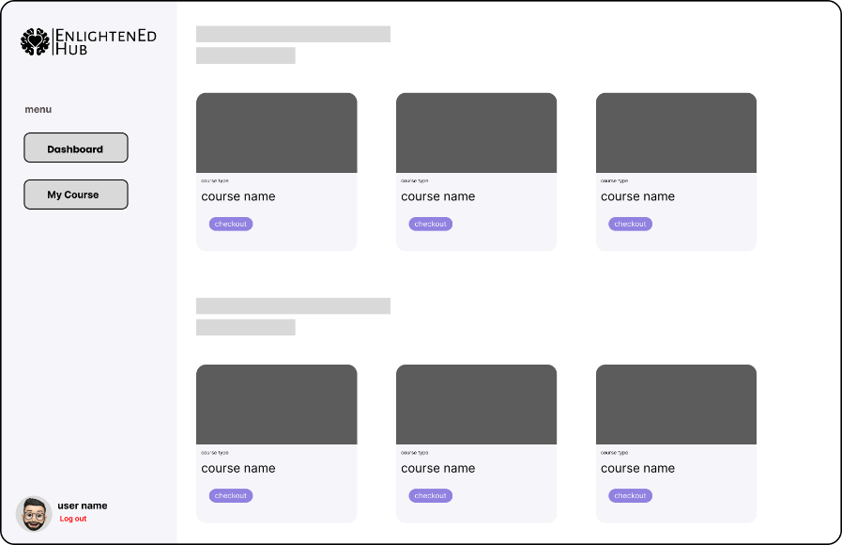

Sign Up

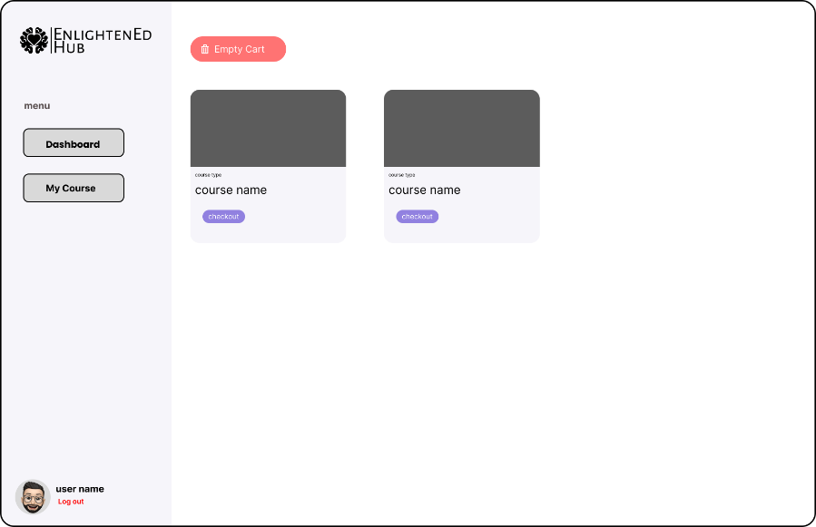

**Front – End Development**

**HTML Structure**:

* Created structured layouts using semantic HTML5 tags to enhance accessibility and SEO.
* Implemented responsive design principles to ensure adaptability across devices.

**CSS Styling**:

* Utilized CSS3 for styling elements, focusing on consistent branding and visual hierarchy.
* Implemented responsive design techniques such as media queries and flexbox/grid layouts for layout adjustments.

**JavaScript Functionality**:

* Developed interactive elements like dropdown menus, sliders, and modals to improve user experience.
* Implemented form validation to ensure data integrity and user input correctness.

**Website – Home Page**



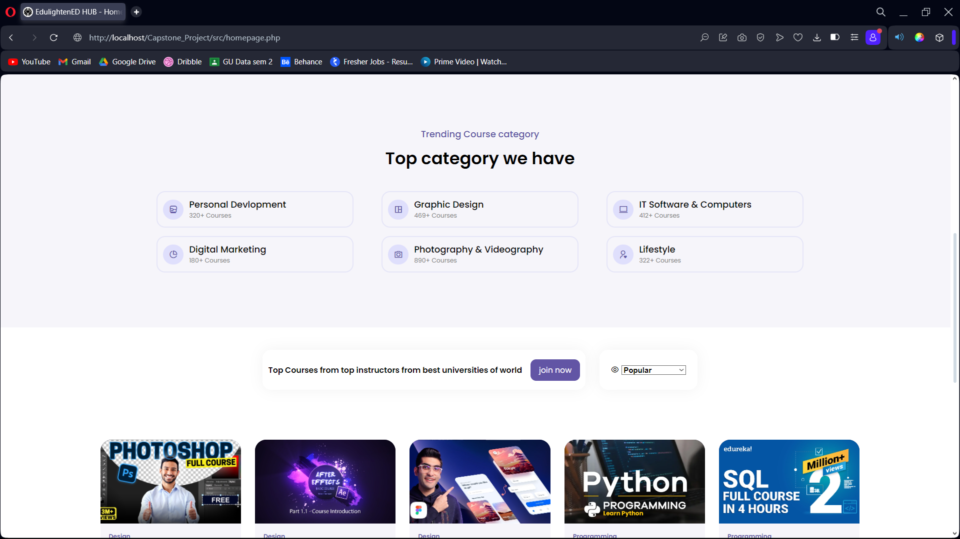

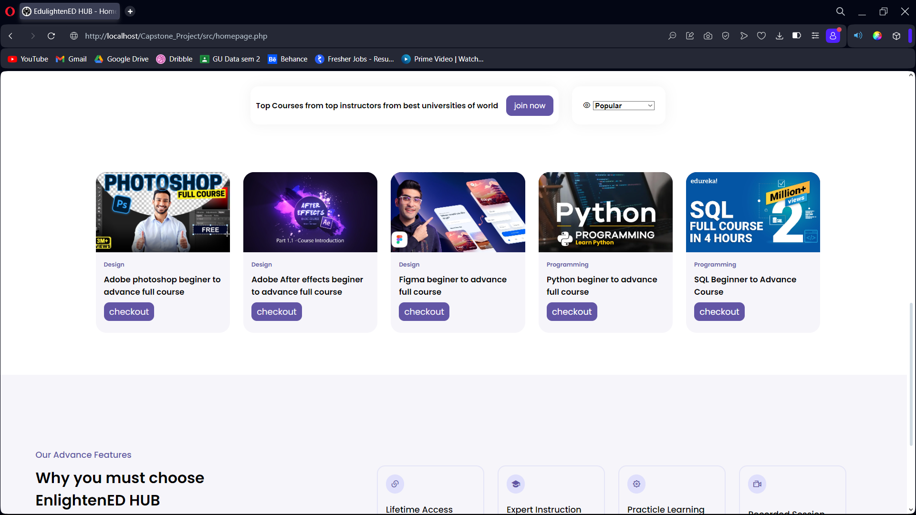

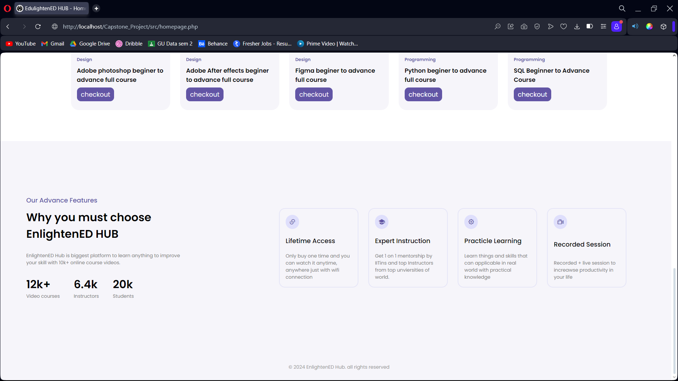

**Website – Sign in page**

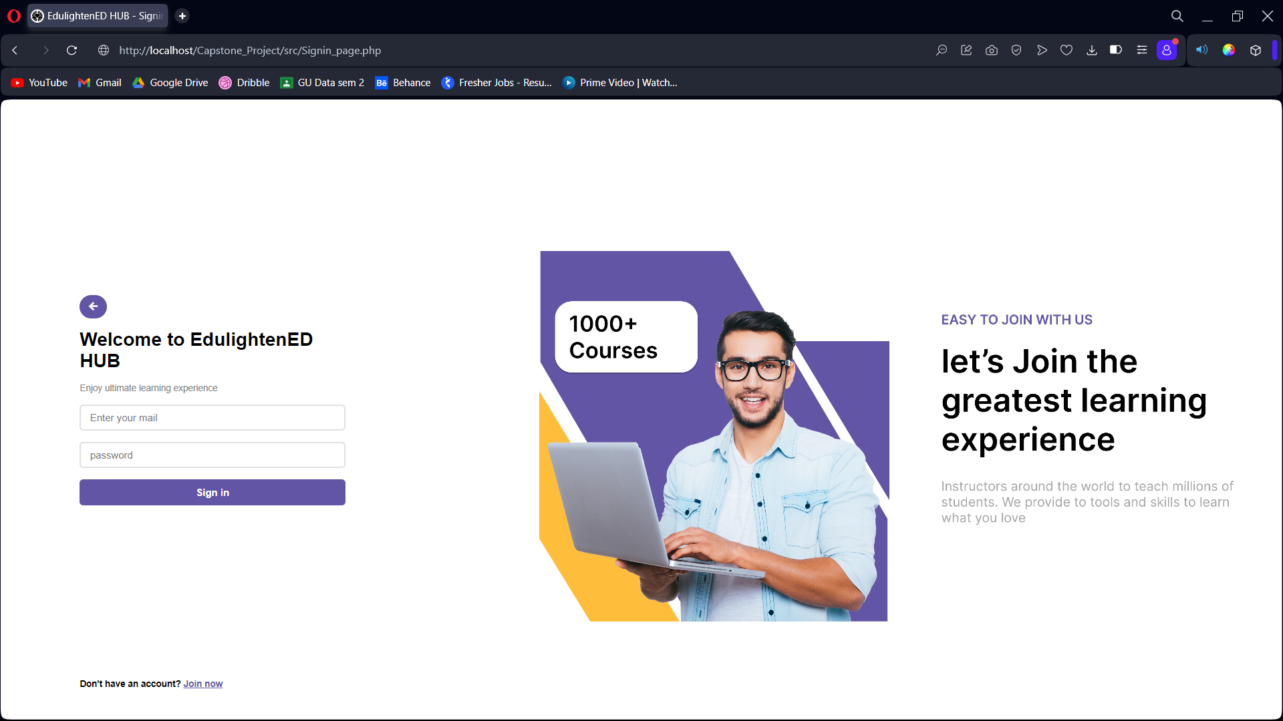

**Website – Sign up page**

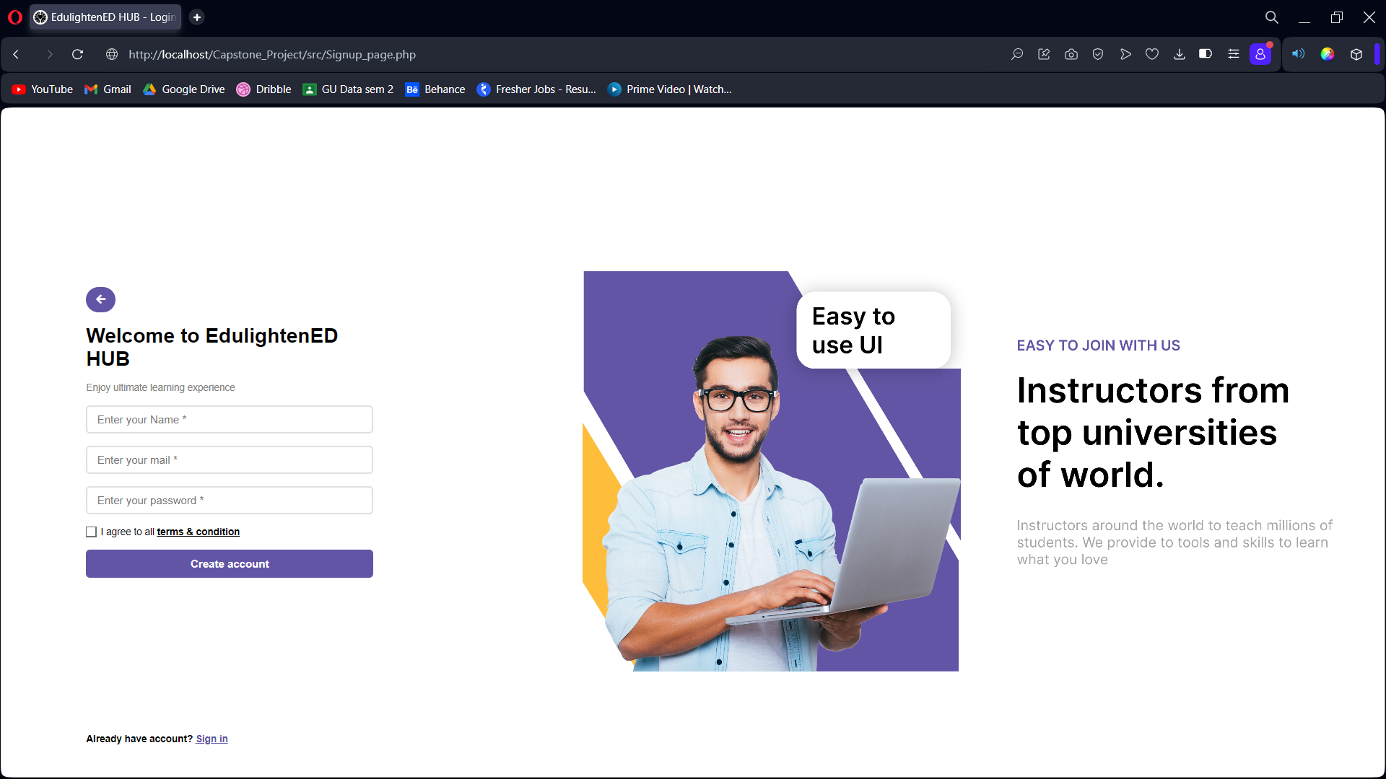

**Website – Dashboard**

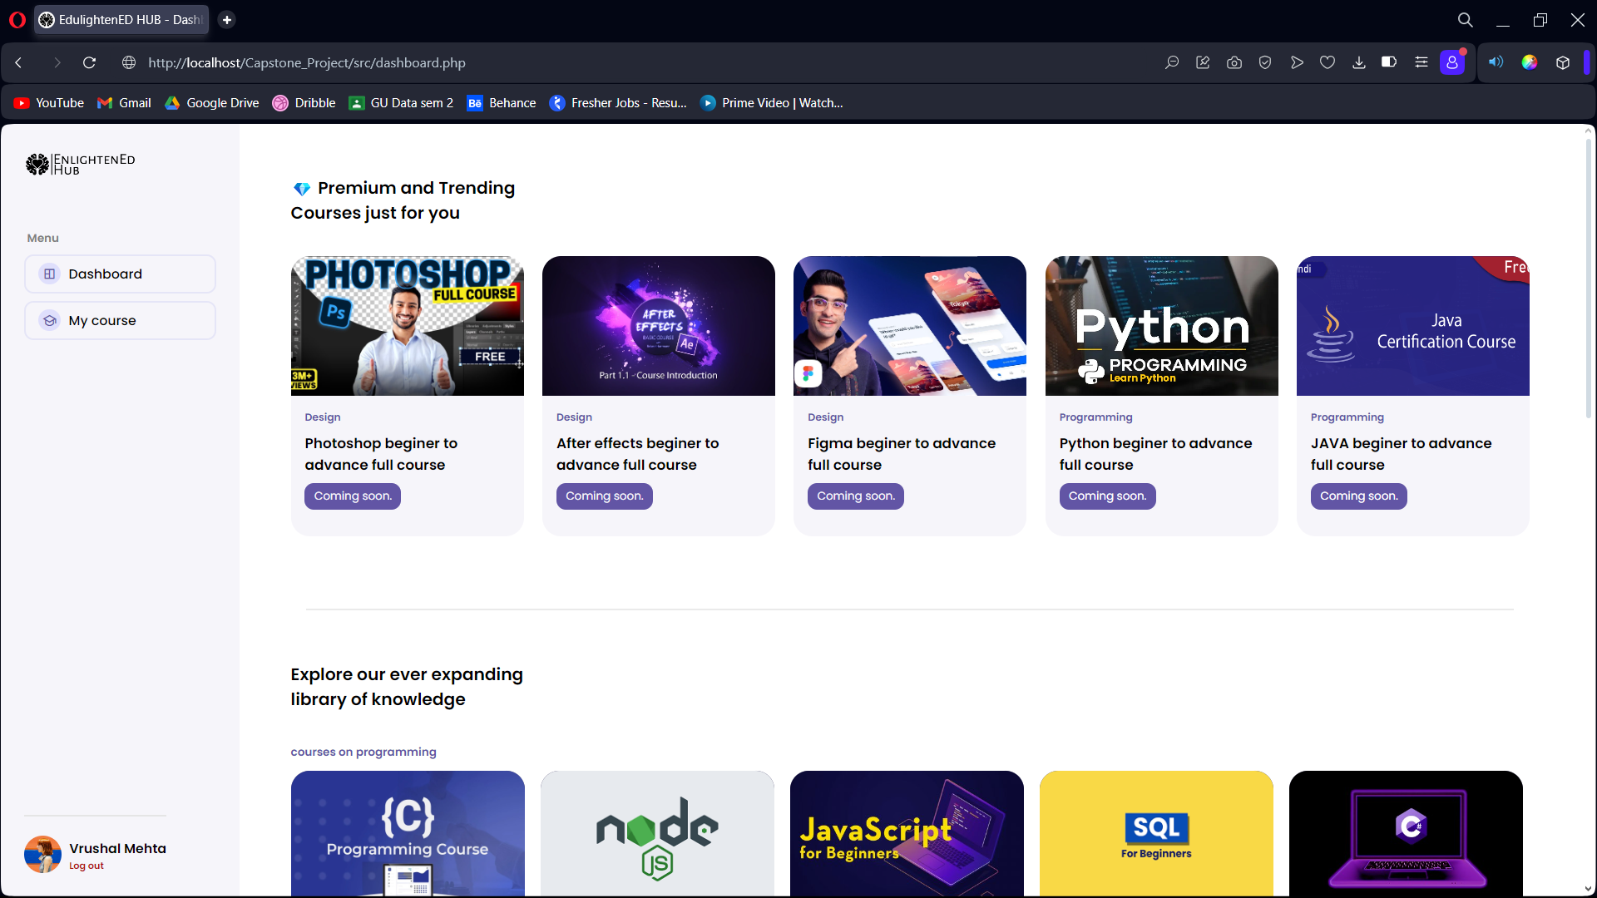

**Website – My Course Page**

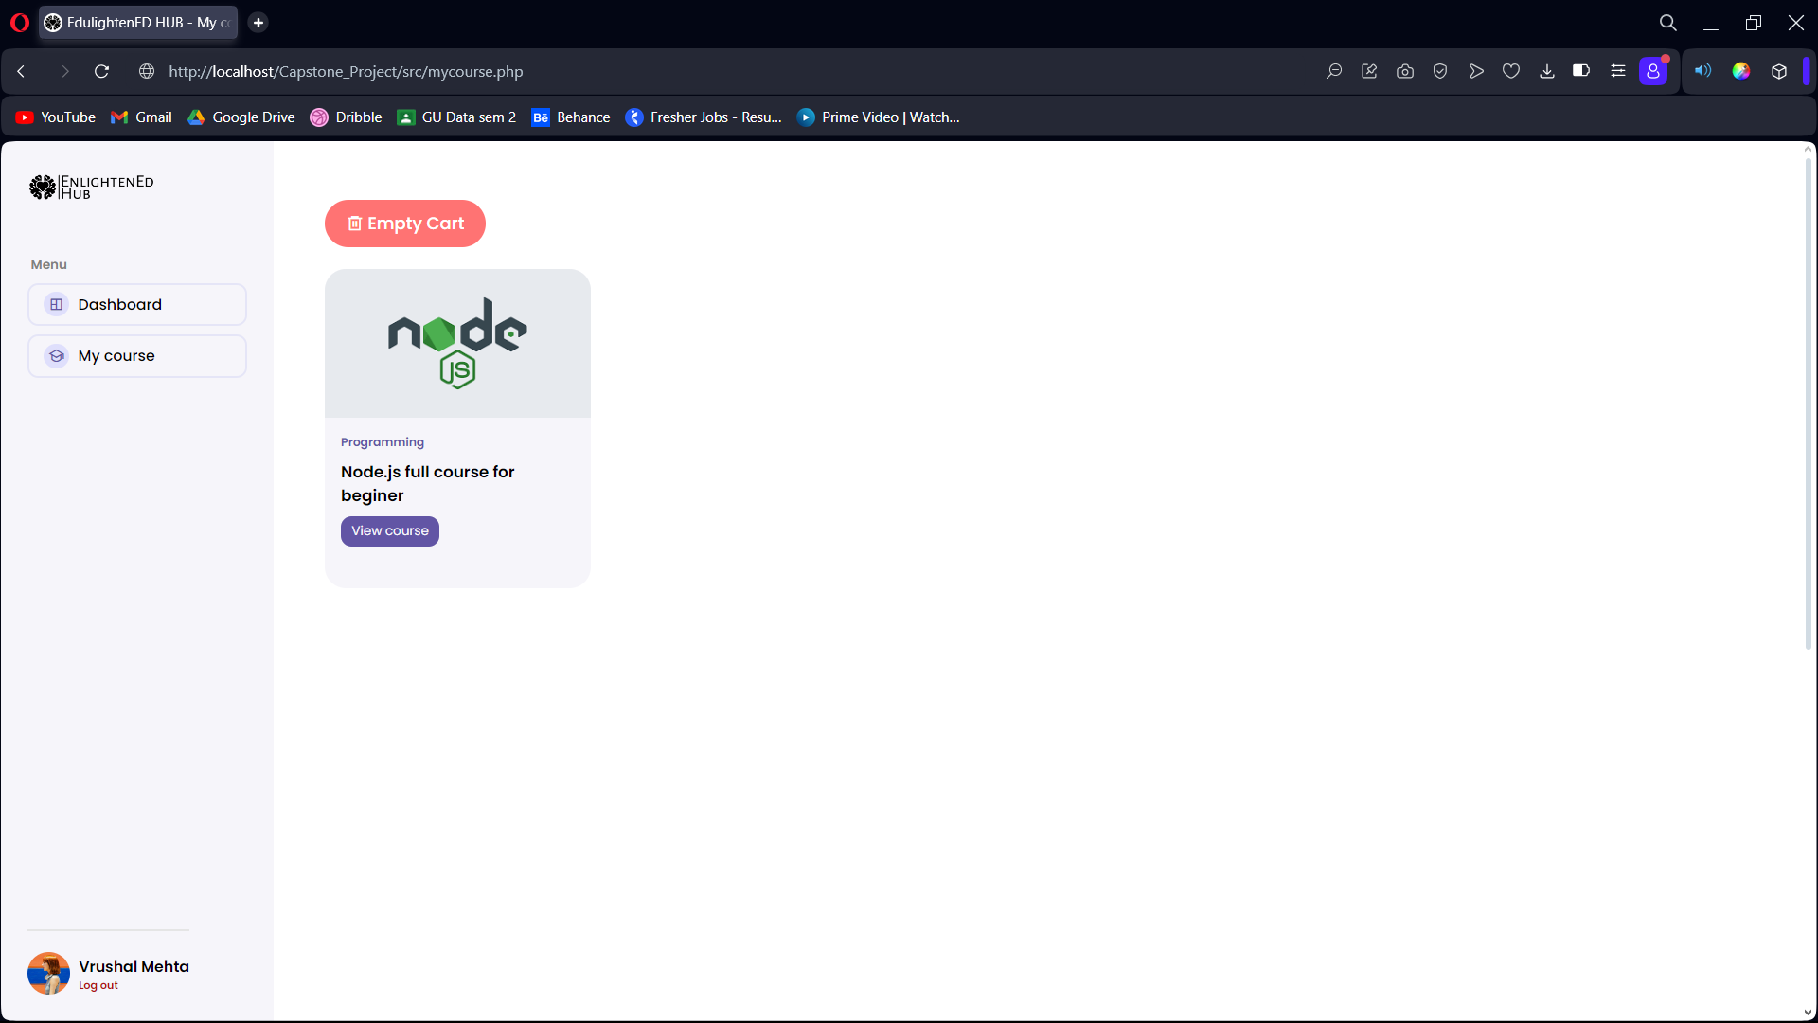

**Website – Course Preview**

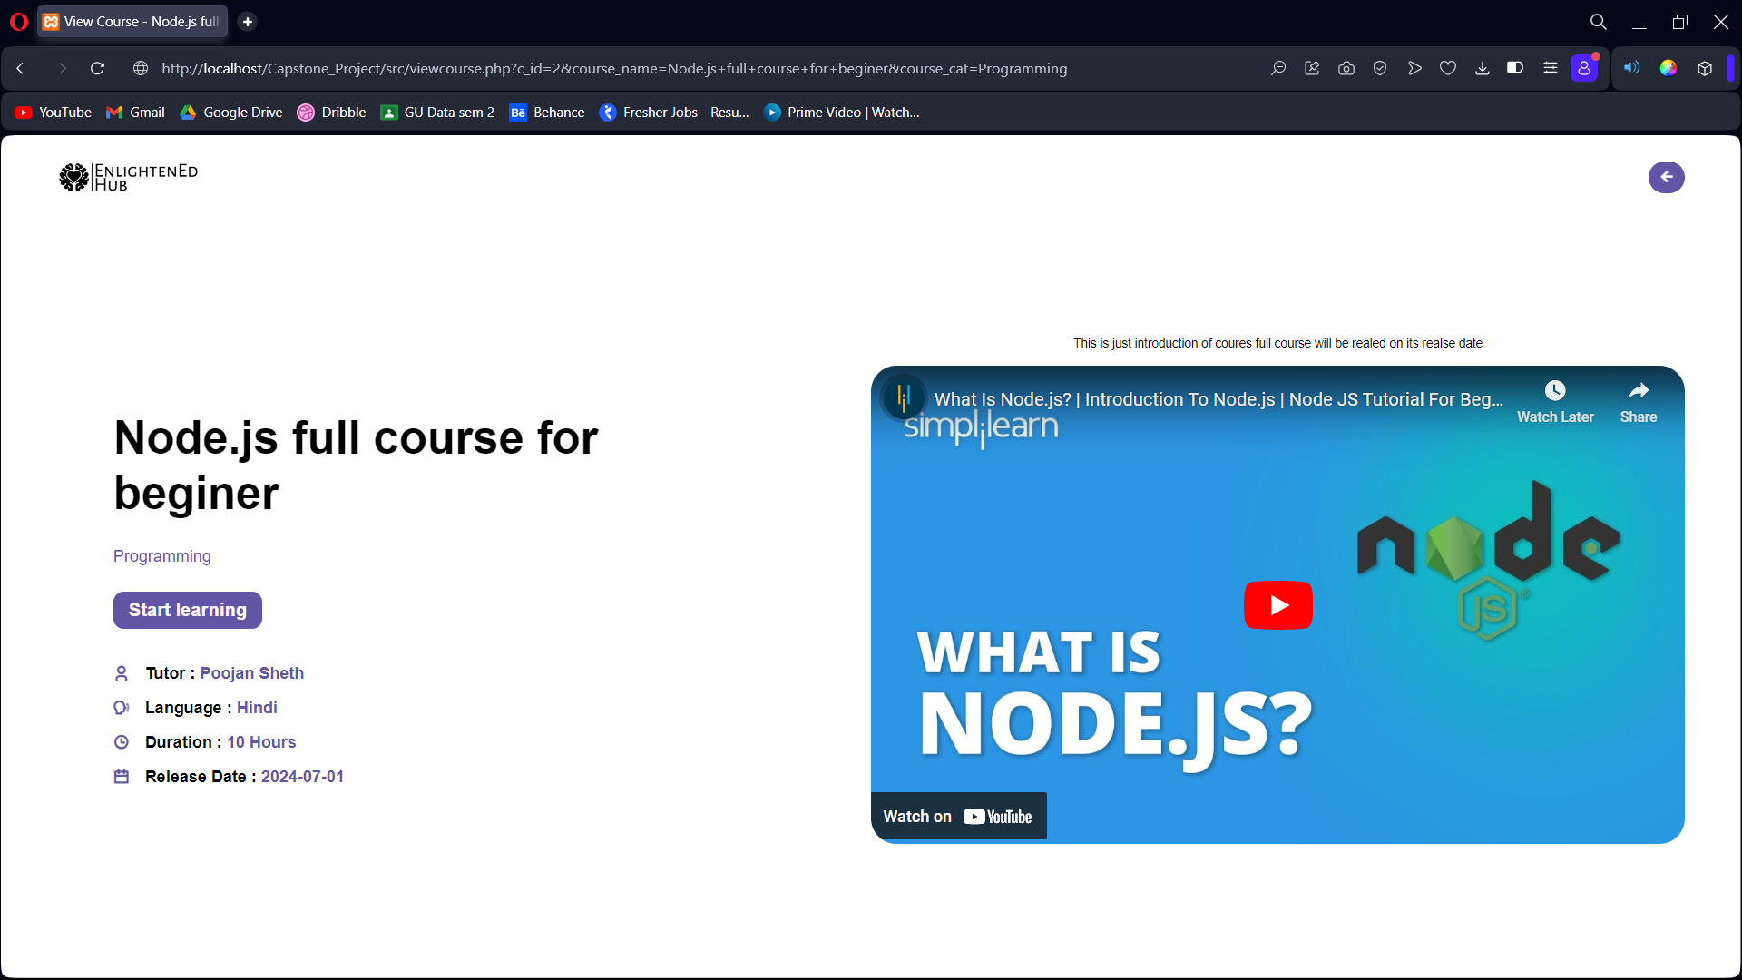

**Website – Contact us Page**

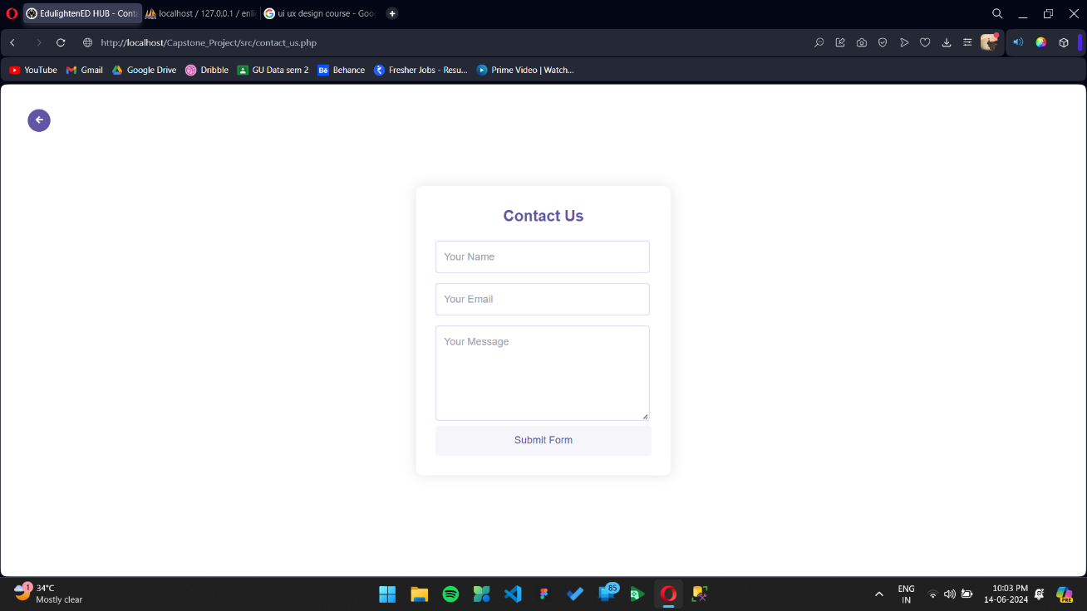

**Integration with Backend**:

* Collaborated with backend developers to integrate frontend components with PHP for dynamic content rendering.
* Ensured seamless data flow and synchronization between frontend and backend systems.

**Backend Development with PHP**

Database Connection with PHP





**Fetching Data from Database**

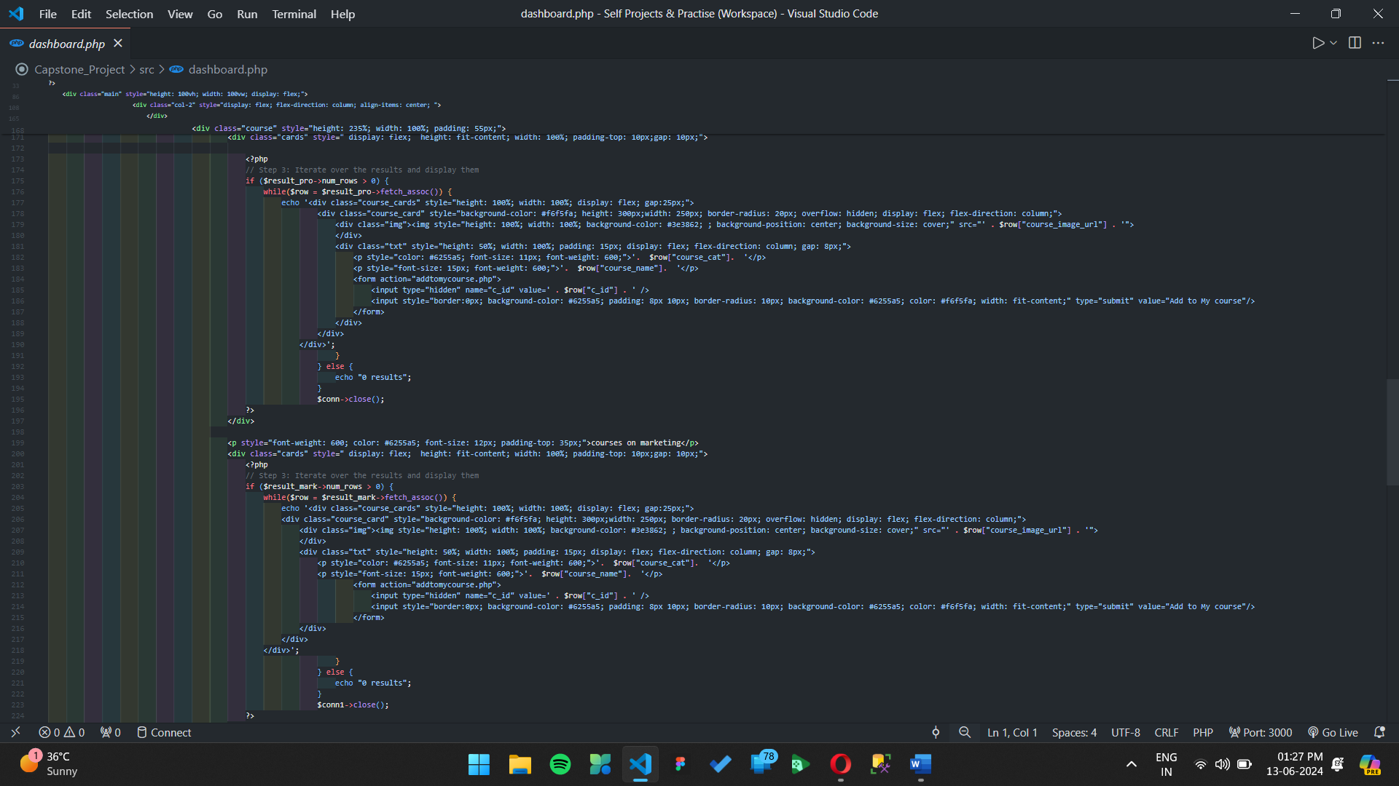

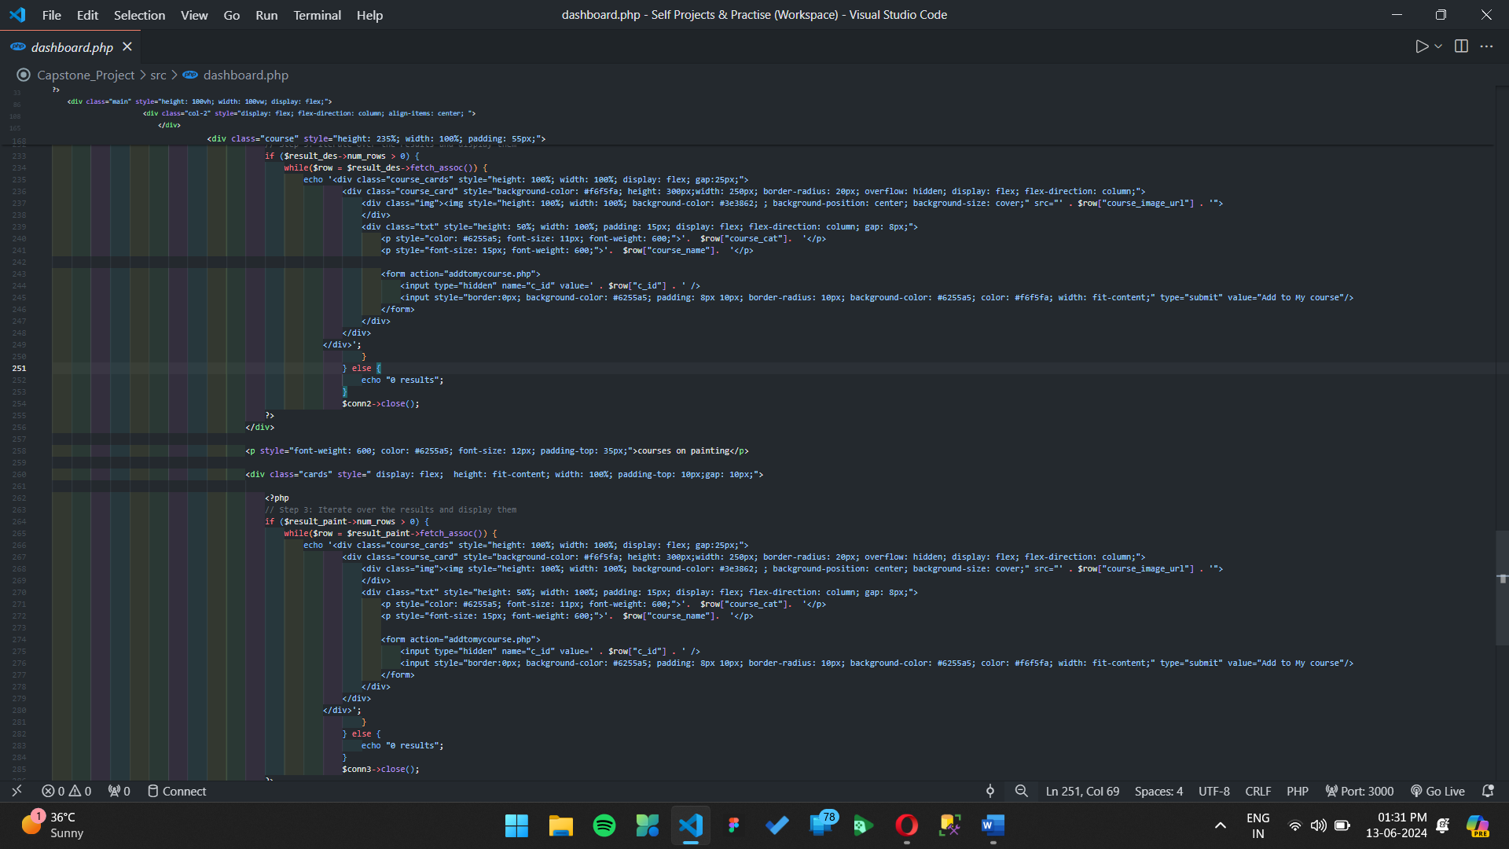

**Database Connectivity**

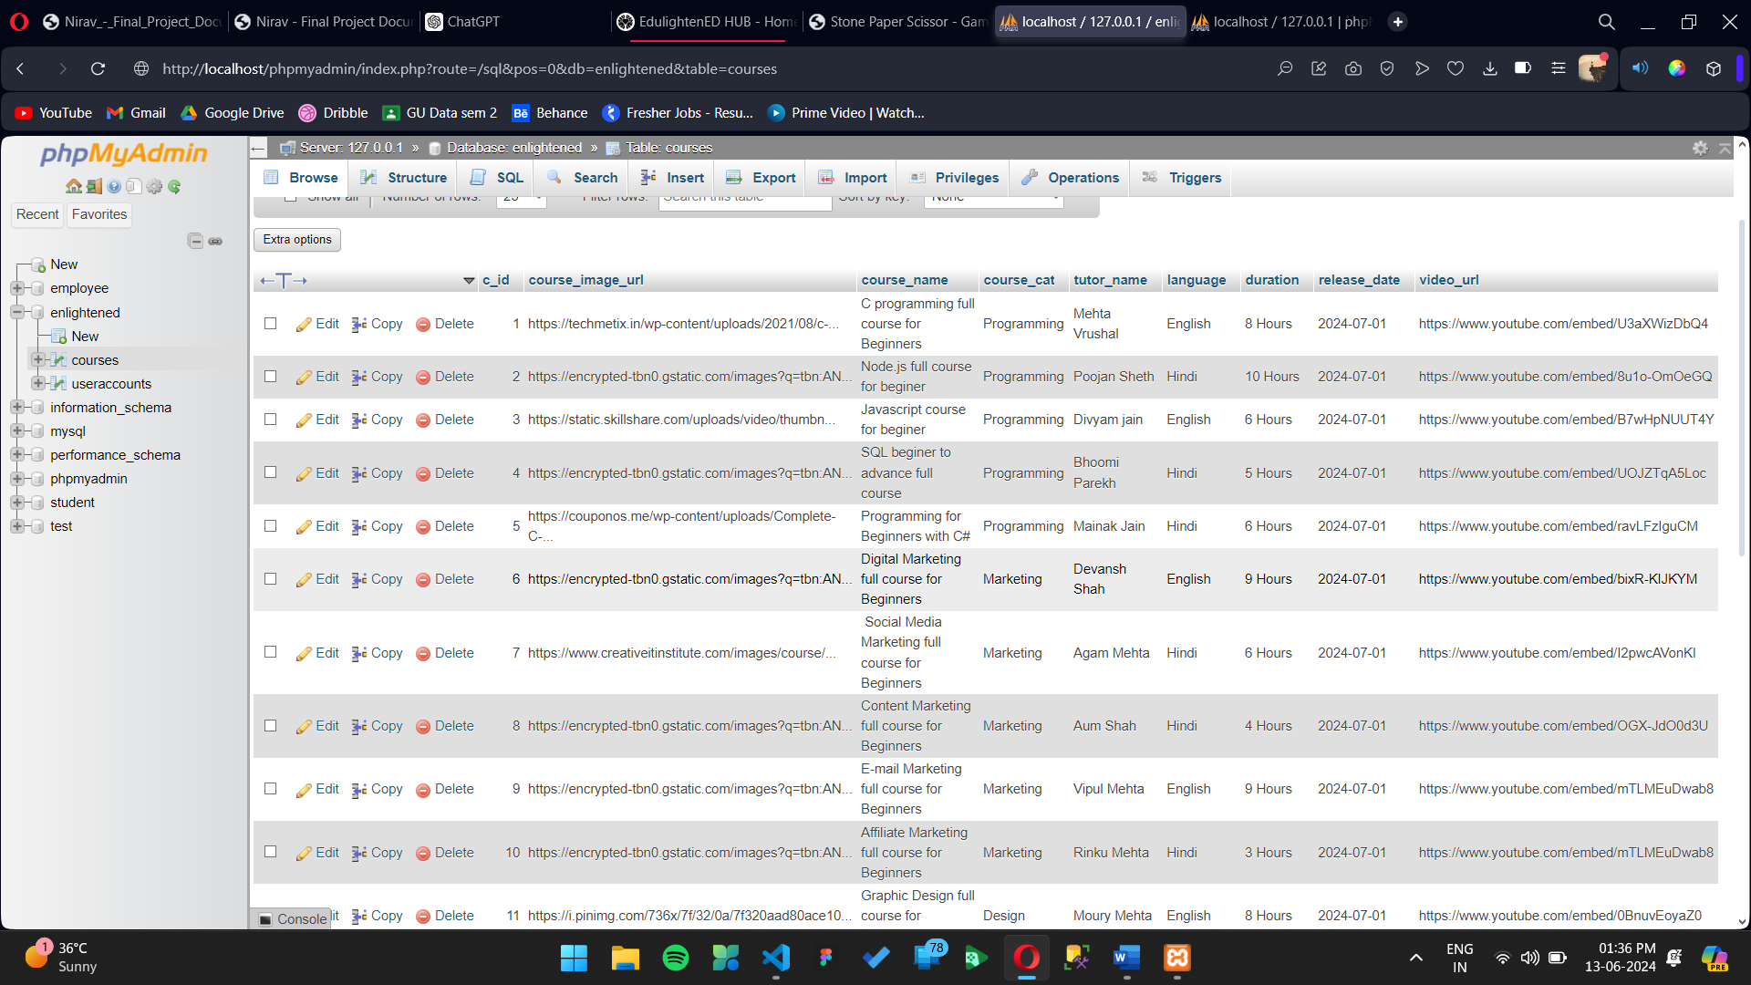

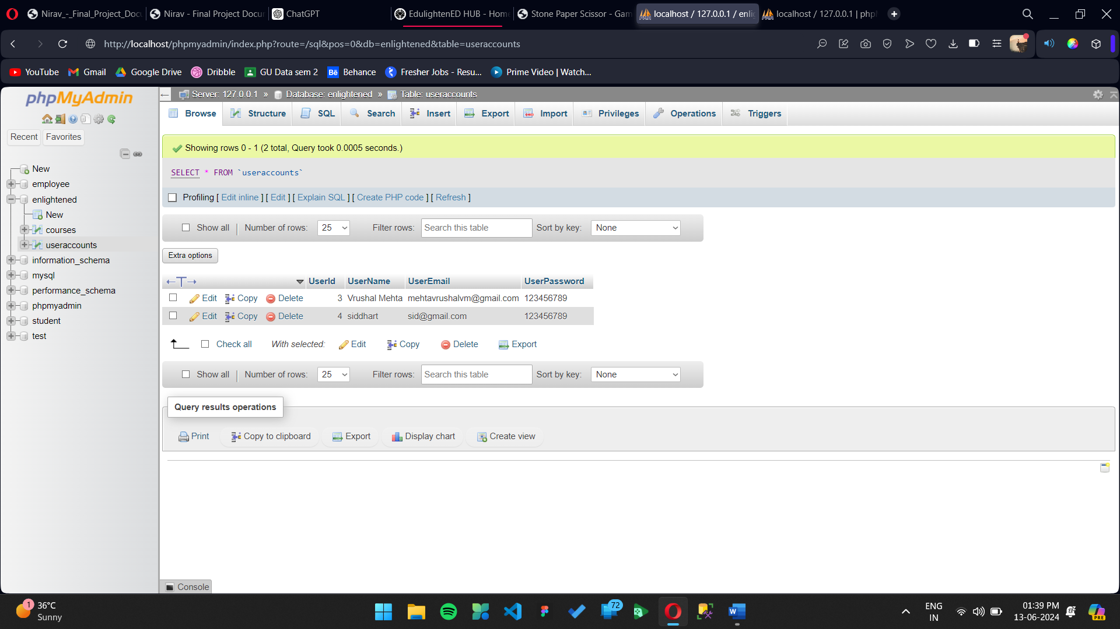

**6. Results**

Implementation of key features

We Implemented all needed features and also added more features like contact us page after getting feedback from our teachers and friends and this page also helps us to get more feedback.

User Feedback

Our contact page helps us to get feedback from user by using W3.forms

Which connects inputs fields to their backend system using API. This helps us to get user information and message from user directly on registered mail address

Contact us page

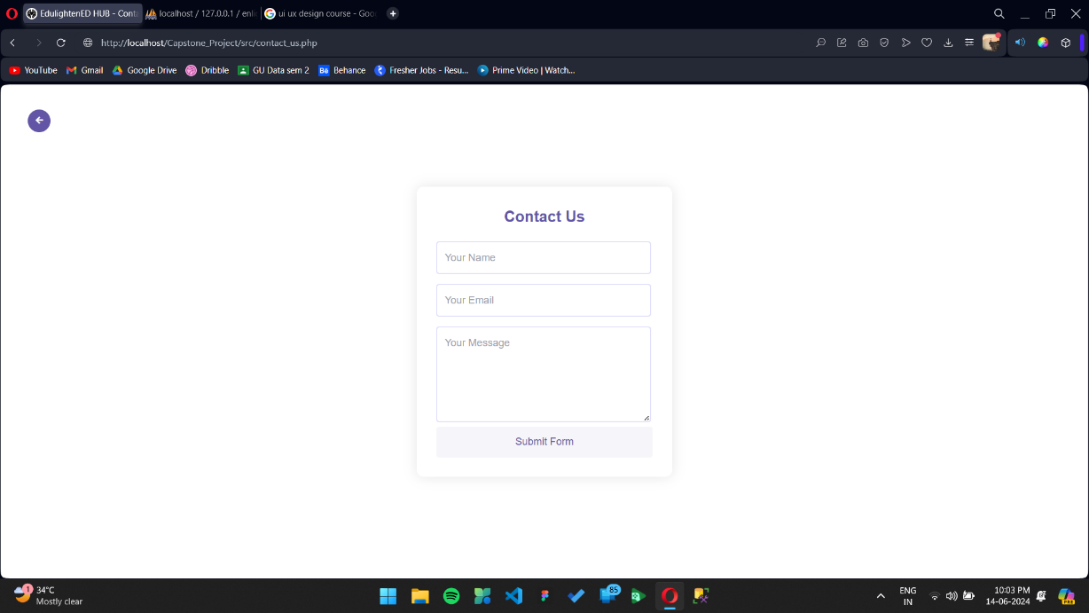

Another change we did after getting feedback was added admin page to our website which can be only accessed by entering specific email & password. Admin panel shows our database in webpage and also allow to add new user, update details of existing user and delete user.

Showing database

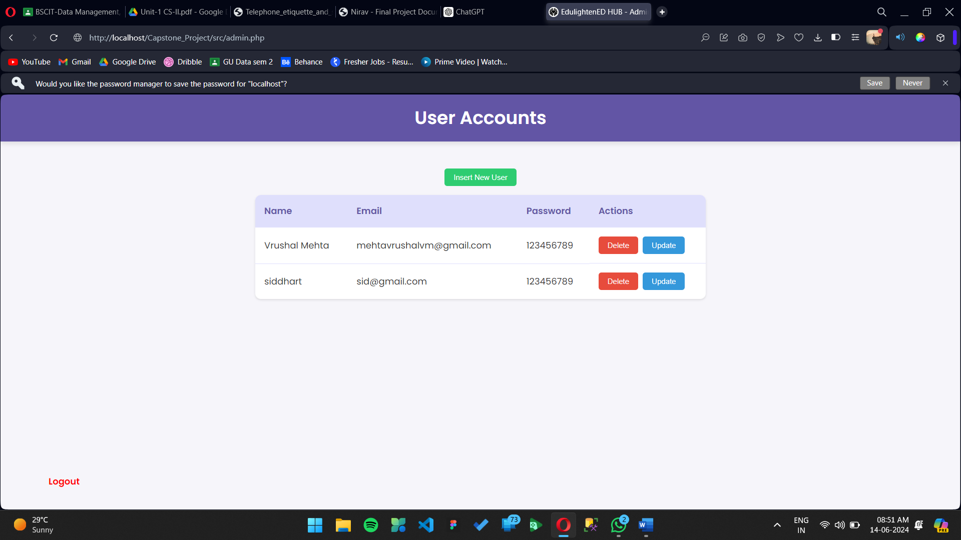

Insert new user  
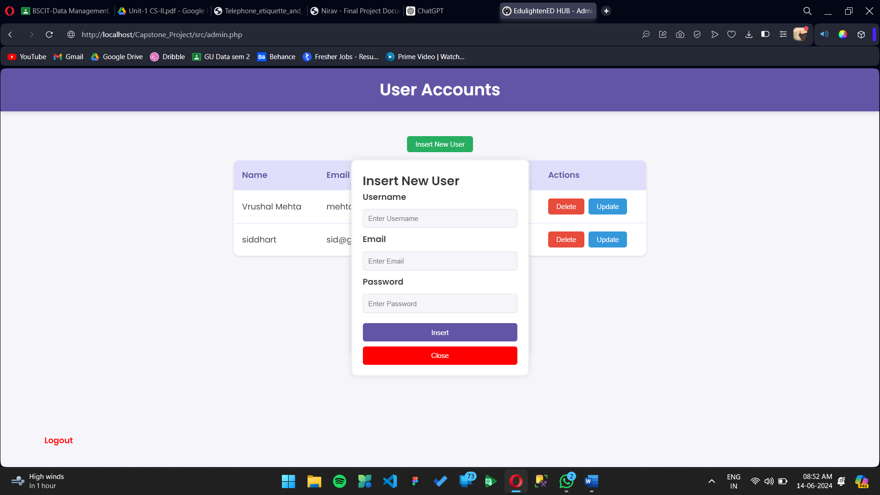

Update user

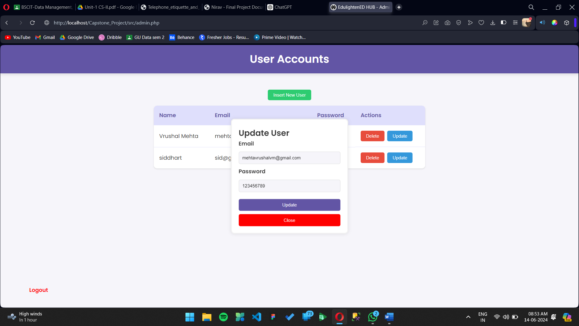

Deleting user

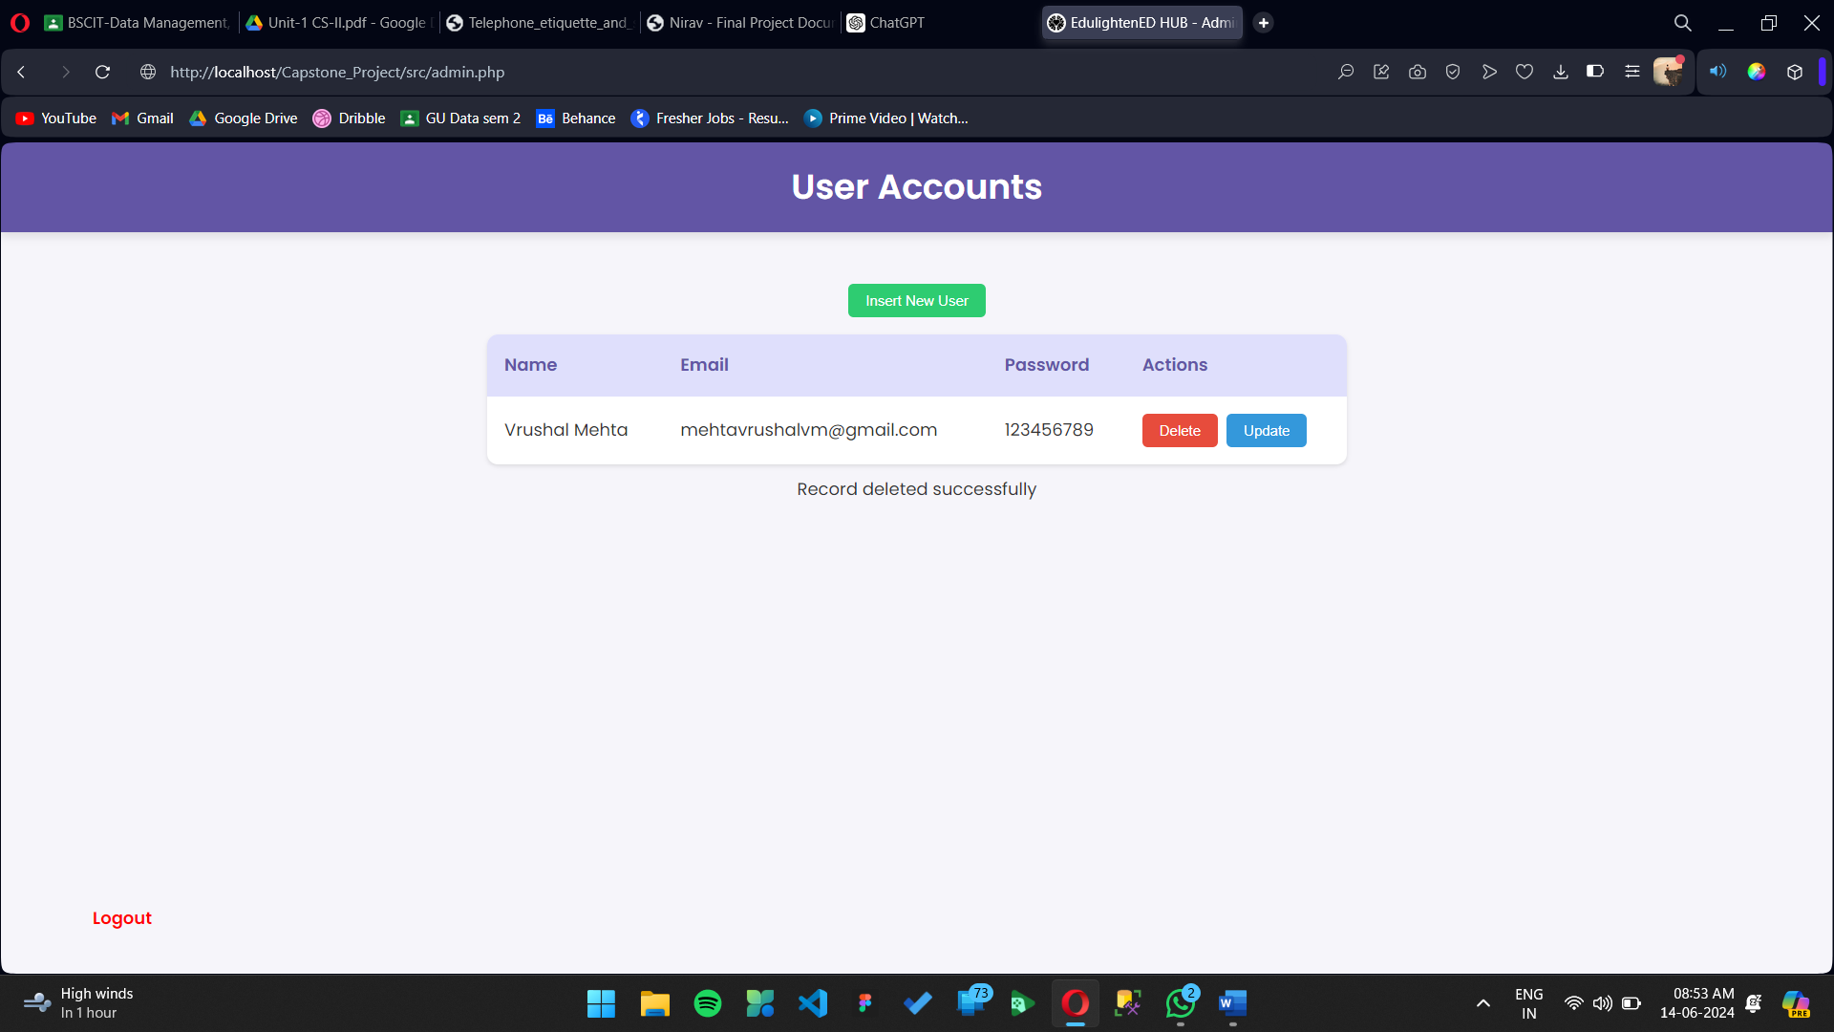

**7. Results**

### Analysis of Results: Enlightened

**User Engagement and Retention:**

Enlightened's user-friendly interface and seamless navigation have led to high user engagement and retention. The secure authentication system ensures personalized access, contributing to user satisfaction. High retention rates reflect the platform's effectiveness in keeping users engaged.

**Course Enrolment and Completion:**

The comprehensive course management system allows users to explore, enrol, and manage their courses easily. High enrolment and completion rates indicate that users find the courses relevant and are actively engaging with the content.

**Personalization and User Satisfaction:**

Personalized recommendations and an intuitive profile management system enhance user experience. Users appreciate the tailored content and the ability to track their progress, leading to increased satisfaction.

**Security and Data Privacy:**

The robust security measures, including encrypted data storage and secure session management, effectively protect user data. No incidents of data breaches have been reported, fostering user trust and confidence in the platform.

**Overall Impact:**

Enlightened has successfully established itself as a comprehensive educational hub, meeting diverse learning needs with a secure, personalized, and engaging experience. High user satisfaction, engagement, and course completion rates highlight its positive impact on online education.

**Future Improvements:**

Future enhancements could include advanced analytics, more customization, expanded course offerings, and interactive features to further enhance user engagement and community building.

In summary, Enlightened has effectively addressed the needs of modern learners through its innovative design, resulting in high user satisfaction and engagement, solidifying its position in the online education space.

### Challenges Faced in Developing Enlightened

**Lack of Experience Using PHP:**

One of the primary challenges encountered during the development of Enlightened was the team's limited experience with PHP. This lack of familiarity led to a steep learning curve, particularly in implementing dynamic features and managing server-side operations. Debugging and troubleshooting PHP code took considerable time and effort, affecting the overall development timeline.

**Limited Knowledge of Sessions and Cookies:**

Another significant challenge was the team's insufficient knowledge of handling sessions and cookies. Implementing features like "Add to My Course" and "Empty Cart" required a deep understanding of session management and cookie handling. Ensuring that user data was correctly stored, retrieved, and manipulated without compromising security was particularly challenging. The team had to invest substantial time in learning and experimenting with PHP sessions and cookies to implement these features effectively.

Despite these challenges, the team persevered, leveraging online resources, tutorials, and community support to overcome obstacles. This learning process, though arduous, ultimately enriched the team's skills and contributed to the successful development of Enlightened's key functionalities.

### 8.Conclusion

Enlightened Hub is a comprehensive course-selling platform meticulously developed using a robust stack of technologies, including HTML, CSS, JavaScript, PHP, SQL, and the XAMPP server. The platform is designed to integrate multiple key features such as user authentication, course management, and enrolment capabilities to deliver a seamless and user-friendly experience. Through the use of HTML and CSS, the website boasts a visually appealing and responsive interface, ensuring a pleasant user experience across various devices.

JavaScript is employed to handle dynamic content updates, providing interactive and real-time functionalities that enhance user engagement. PHP and SQL are integral to the backend operations, managing secure data handling, user sessions, and database interactions efficiently. The XAMPP server serves as a reliable local development environment, facilitating smooth server-side scripting and database management.

Enlightened Hub's course management system allows administrators to easily add, update, and manage course content, while the enrolment feature streamlines the process for users to register and track their courses. By leveraging this integrated technology stack, Enlightened Hub ensures secure, efficient, and scalable operations, making it a robust and effective solution for the online education market.